Covid Case Rates, 1st and 2nd Differences

Brandon Tao

10/12/2020

### 0. Setup

library(tidyverse)  
library(micromapST)  
load('Data/Covid_Rates_Two_Week_Gaps.RData')  
objects()

## [1] "caseRates3" "deathRates3" "st_caseRates3" "st_deathRates3"

### 1. Arrow plots

Addressing plot appearance in a constrained space poses challenges that call for decisions. One goal is to simplify appearance. Here the units of measure label, ‘Cases per 100,000’, is long. It has been shortened a little.

The x-axis grid line units are 4 digits long. Rescaling the units to percents is thinkable. Then there would be only one digit each.

Choices can be guided by the target audience. Those in the health sciences are likely think in terms of rates such as rate per 100,000 or rate per million. In criminology rates per 1000, and 10,000 are likely more common. Much of public is more familiar with percents.

The general strategy is have two or may three digits to the left of the decimal place. This can motivate taking logs. Graphics and and modeling can also call for taking logs.

dat <- as.data.frame(st_caseRates3)  
names(dat)

## [1] "Postal" "Sep_11_2020" "Sep_25_2020" "Oct_09_2020"   
## [5] "Name" "Fips" "Pop" "Sep_11_2020_R"  
## [9] "Sep_25_2020_R" "Oct_09_2020_R"

panelDesc1 <- data.frame(  
 type = c('maptail','id','arrow','arrow','arrow'),  
 lab1 = c('','','Sept. 11 and','Sept. 25 and','Sept. 11 and'),  
 lab2 = c('','','Sept. 25','Oct. 9','Oct. 9 '),  
 lab3 = c('','','Cases per 100K','Cases per 100K','Cases per 100k'),  
 col1 = c(NA,NA,'Sep_11_2020_R','Sep_25_2020_R','Sep_11_2020_R'),   
 col2 = c(NA,NA,'Sep_25_2020_R','Oct_09_2020_R','Oct_09_2020_R')   
)  
  
  
micromapST(dat, panelDesc1,  
 rowNamesCol = 'Postal',  
 rowNames = 'ab',  
 sortVar = 'Sep_11_2020_R', ascend = TRUE,  
 title = c("Covid-19: Two-Week Case Rate Changes",  
 "Fridays: Sept. 11 to Oct. 9, 2020 ")  
)

## End of micromapST processing.

## No warnings were logged.

## No stop messages were logged.

##

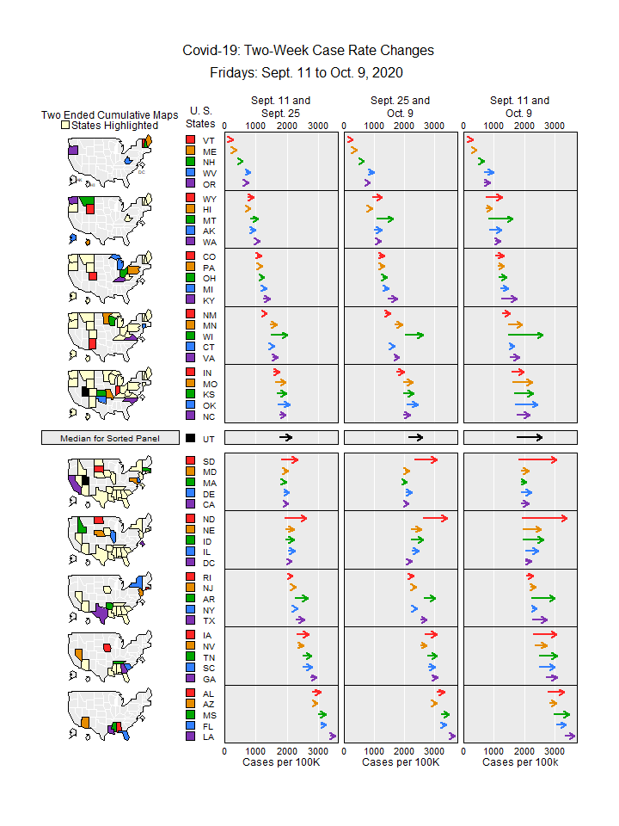

## [1] "micromapST Ends"

Describing the plots will be address in class. The focus here is on plot production.

I often mistakes in the panel description dataframe. The micromapST function provides feedback that can be helpful in identifying problems. When using an R scriptthe feedback is likely to appear on Console. When using RMD files some feedback appears little panel below the script chuck. There is very little yellow warning triangle in the panel. Clicking on the panel reveals messages.

For this example, the message I saw indicated that variables specified were not found. That was a good clue. I had typed lower case r’s and not upper case R’s in the variables names.

On occasion I misspell the sorting variable name. Then, with no other problems, micromapST will produce the plot without sorting, and provide a warning message. The lack of sorting is obvious in the plot but sometimes people in a hurry and assume the plot produced is what they intended.

### 2. Compute First and Second Differences

For time series, second differences provide discrete analogues to the second derivatives in continuous time series. Trends usually do vary over time. With Covid-19 many variables drive the change in the trends. We don’t know them all, and often don’t have data on the variables that we conjecture. Here we look at just one second difference.

names(st_caseRates3)

## [1] "Postal" "Sep_11_2020" "Sep_25_2020" "Oct_09_2020"   
## [5] "Name" "Fips" "Pop" "Sep_11_2020_R"  
## [9] "Sep_25_2020_R" "Oct_09_2020_R"

tib <- select(st_caseRates3,Postal,Sep_11_2020_R:Oct_09_2020_R)  
names(tib)<- c('Postal','Fri1','Fri2','Fri3')  
tibDif <- mutate(tib,  
 dif1=Fri2-Fri1,  
 dif2=Fri3-Fri2,  
 dif3=dif2-dif1)

### 3. Show the differences using micromapST

dat <- as.data.frame(tibDif)  
names(dat)

## [1] "Postal" "Fri1" "Fri2" "Fri3" "dif1" "dif2" "dif3"

panelDesc2 <- data.frame(  
 type = c('maptail','id','dot','dot','dot'),  
 lab1 = c('','','Sept. 25 -','Oct. 9 -','Change in'),  
 lab2 = c('','','Sept. 11','Sept. 25','Differences'),  
 lab3 = c('','','Cases per 100K','Cases per 100K','Cases per 100k'),  
 col1 = c(NA,NA,'dif1','dif2','dif3')  
)  
  
  
micromapST(dat, panelDesc2,  
 rowNamesCol = 'Postal', # Use this column  
 rowNames = 'ab', # Names are State Postal codes   
 sortVar = 'dif3', ascend = TRUE,  
 title = c("First and Second Case Rate Differences",  
 "Fridays: Sept. 11 to Oct. 9, 2020 ")  
)

## End of micromapST processing.

## No warnings were logged.

## No stop messages were logged.

##

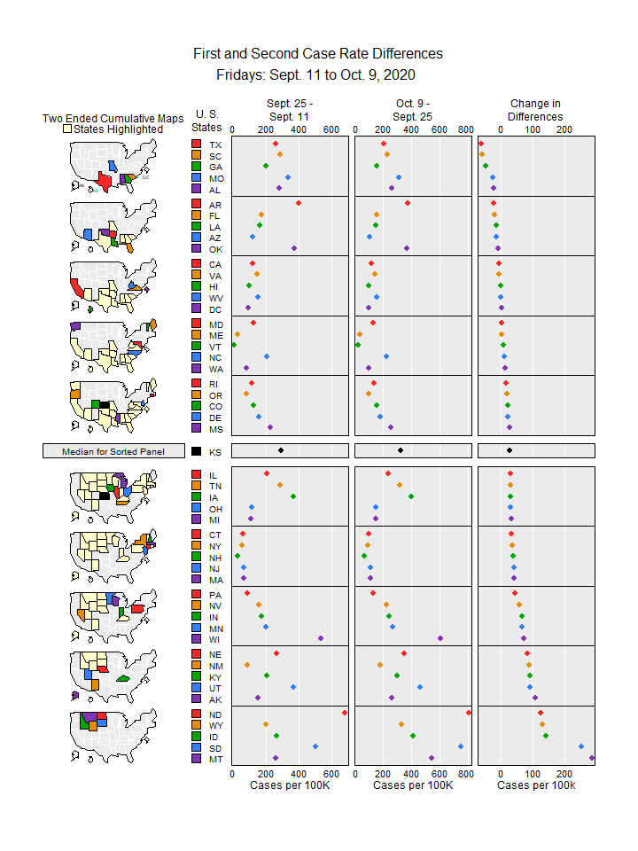

## [1] "micromapST Ends"